**Team Number: 574**

**PROJECT TITLE: HOTEL MANAGEMENT SYSTEM**



**HOTEL:** **Tranquil Haven Inn**

**GROUP MEMBERS:**

* **CHINNAPAREDDY VENKATA CHAITANYA REDDY 20BCI7204**
* **JUJJAVARAPU SUJAN CHOWDARY 20BCI7294**
* **KARAKA RUPASREE 20BCI7108**
* **NANABALA GNANA PRAVALIKA 20BCE7616**

**Table Of Content**

|  |  |  |
| --- | --- | --- |
| **S No** | **Title** | **Page No** |
| 1 | **Introduction** |  |
| **2** | **Overall Description** |  |
| **3** | **System Features and Requirements** |  |
| **4** | **Functional and Non-functional Requirements** |  |
| **5** | **Performance Requirements** |  |
| **6** | **Technical Issues** |  |
| **7** | **Modelling UML Use Case Diagram** |  |
| **8** | **Activity Modelling of Admin** |  |
| **9** | **Activity Modelling of Receptionist** |  |
| **10** | **Annexure (Sample Screens)** |  |

**Identifying the Requirements from Problem Statements (SRS):**

1. **Introduction:**
   1. **Purpose:**

The purpose of this report is to explore and evaluate the implementation of a comprehensive hotel management system. This system aims to streamline and optimize various operational aspects of hotel management, including Employee Details, Driver Details, Room Details, Room Booking, Check In and Check Out Sections, Amount Pending Details, and Staff Scheduling. By integrating these functions into a centralized software solution, the hotel management system aims to enhance efficiency, improve guest satisfaction, and ultimately contribute to the overall success and profitability of the hotel industry.

* 1. **Intended Audience:**

Stakeholders – Hotel manager, HR system managers, central Finance officers

Users – Employees, Staff, Workers

* 1. **Intended Use:**

The hotel management system is designed to provide a user-friendly platform for hotel employees to monitor their salaries, including withholding taxes, attendance, and other deductions. It enables stakeholders to easily verify employee work hours and leaves, ensuring accurate salary credits. By facilitating transparent and efficient payroll management, the system aims to minimize major problems and financial issues. Ultimately, the intended use of the hotel management system is to streamline payroll processes, enhance employee satisfaction, and reduce financial discrepancies for improved operational efficiency.

* 1. **Overview:**

The Hotel Management System project aims to streamline hotel operations using Spring Boot. It provides an easy-to-use web application for admins to manage employees, rooms, and drivers. Additionally, admins can access new customer registration forms, room and customer information, checkout functionality, and room search and update features. The system enhances efficiency and customer service, making it a valuable tool for hotel administration.

**2 Overall Description:**

The Hotel Management System is a comprehensive project built on Spring Boot, designed to optimize hotel operations. It offers a user-friendly web application for admins, empowering them to efficiently manage employee, room, and driver details. The system also provides essential functionalities for customer management, including new customer registration forms, room and customer information access, checkout process, and room search and update features. By leveraging the power of Spring Boot, the project ensures seamless integration, scalability, and security, ultimately enhancing overall hotel efficiency and customer satisfaction. This system is an asset for any hotel seeking to streamline operations and deliver exceptional guest experiences.

**2.1 Purpose:**

The purpose of the Hotel Management System using Spring Boot and MySQL is to provide a comprehensive and user-friendly platform for efficient hotel management. It aims to automate various manual processes, such as employee, room, and driver registration, while enhancing the overall customer experience by enabling easy access to booking information, customer details, and room availability. By centralizing data in a MySQL database and leveraging the power of Spring Boot, the system will streamline operations, optimize resource allocation, and facilitate smooth interactions between admin and hotel staff, ultimately leading to increased productivity and customer satisfaction.

**2.2 Advantages:**

The Hotel Management System using Spring Boot and MySQL offers several advantages. Firstly, it automates mundane tasks like employee and room management, reducing manual errors and saving time. Secondly, it enhances customer experience by providing a user-friendly interface for booking, accessing room information, and updating customer details. Thirdly, with a centralized MySQL database, data is secure and easily accessible for analysis and decision-making. Additionally, the system enables efficient resource allocation and planning, leading to optimized operations and improved productivity. Lastly, it facilitates better communication between admin and hotel staff, ensuring prompt service and higher levels of customer satisfaction, ultimately benefiting the hotel's reputation and profitability.

* 1. **Disadvantage:**

1. Possible system vulnerabilities and security risks due to web-based nature.

2. Dependency on internet connectivity for access, leading to potential disruptions.

* 1. **Admin needs:**

**Admin should be familiar terms like:**

* Login
* Add Room
* Add Driver
* Add Employee
* New Customer Form
* Customer info
* Update Status
* Checkout
* Room
* Room Info
* Update Room Status
* Room Search
  1. **Receptionist needs:**

**Receptionist should be familiar terms like:**

* Login
* New Customer Form
* Customer info
* Update Status
* Checkout
* Room
* Room Info
* Update Room Status
* Room Search

**2.6 Principle Actors:**

The two Principal Actors are Receptionist (Staff User) and Administrator (Stakeholder).

**2.7 General Constraints:**

An internet connection is required for HMS.

1. **System Features and Requirements:**

**3.1 Functional Requirements:**

This section gives a high-level summary of the system's requirements. The system will be able to implement a variety of functional modules, including:

**3.1.0 Login:**

The user logs in to the online application using a valid employee email-id and password that has been successfully validated by selecting that your status by selecting either employee or admin.

**3.1.1 Add Employee:**

Every new employee detail entered here by admins. Here employee details like personal information, class, department name and salary details of the employee in the Hotel.

**3.1.2 Add Room:**

Admins can create and add new rooms to the hotel using this feature. The room details, such as bed type, Availability, Cleaning Status and pricing, can be specified during the room creation process.

**3.1.3 Add Driver:**

This feature enables admins to add new drivers to the system. Admins can enter the driver's personal information, contact details, driving license details, and any other relevant information required for managing transportation services in the hotel. By adding drivers through this functionality, the hotel can efficiently manage its transportation fleet and ensure smooth guest transportation services.

**3.1.4 New Customer Form:**

The New Customer Form allows customers to provide their details when making a reservation or checking in at the hotel. Customers can fill in their personal information, contact details, preferred room type, number of days, and any special requests they may have. This form serves as a convenient and user-friendly way for customers to communicate their preferences and requirements, helping the hotel staff to provide a personalized and pleasant experience during their stay.

**3.1.5 Room:**

The Room Info section provides comprehensive details about the various rooms available in the hotel. Customers and staff can access this information to know the room types, cleaning status, availability, and pricing. Additionally, the room availability status is displayed, allowing customers to make informed decisions while booking. The Room Info feature streamlines the room management process, ensuring efficient allocation of rooms and enhancing the overall guest experience by providing transparent and up-to-date room information.

**3.1.6 Employee Info:**

The Employee Info section presents a comprehensive overview of all the hotel's employees. It includes details such as their names, department affiliations, contact information, and salary details. This feature allows management and other authorized personnel to access and review the employee information, facilitating effective workforce management, payroll processing, and communication. The Employee Info section ensures that the hotel has a centralized and organized system to manage its workforce efficiently and provides valuable insights into employee performance and allocation within the organization.

**3.1.7 Customer Info:**

The Customer Info section provides a centralized database of customer details who have checked-in or made reservations at the hotel. It includes information such as customer names, contact details, number of days, room preferences, and any special requests or notes. This feature allows hotel staff to access and update customer information, ensuring personalized services, efficient communication, and a seamless guest experience. Having access to customer details through the Customer Info section enables the hotel to cater to individual needs, track guest preferences, and maintain a high level of customer satisfaction.

**3.1.8 Check Out:**

The Check Out feature allows hotel staff to efficiently complete the departure process for guests who have completed their stay. Upon check-out, the system updates the customer's status, releases the room for future bookings, and calculates the final bill based on the services availed during the stay. This feature streamlines the check-out process, ensuring a smooth and hassle-free experience for both guests and staff. By automating the check-out procedure, the hotel can optimize its operations, reduce waiting times, and provide a satisfactory departure experience for its valued guests.

**3.1.9 Update Status:**

The Update Status feature enables admins or authorized staff to modify and update the status of rooms and services within the hotel management system. This includes updating the days of rooms, customer contact info, customer name, room type. Additionally, the feature allows staff to update the status of services like cleaning, maintenance, and transportation availability. By utilizing the Update Status functionality, the hotel can efficiently manage resources, ensure accurate room and service allocations, and maintain real-time information for both staff and guests, resulting in an enhanced overall guest experience.

**3.1.10 Pick Up Service:**

The Pick-Up Service feature provides a convenient way for customers to request transportation from the hotel, such as airport pick-ups or local transfers. Customers can specify their pick-up location and car. Hotel staff can then manage and schedule these pick-up requests, ensuring timely and comfortable transportation for guests. The Pick-Up Service feature enhances guest convenience and satisfaction, as it simplifies transportation arrangements and allows the hotel to offer a reliable and efficient transportation service, contributing to a positive overall guest experience.

**3.2 Non-functional Requirements:**

In the insurance to the internet, the following Non-functional Requirements will be present:

1. Secure access to a customer's personal information.
2. Availability 24 hours a day, 7 days a week.
3. Improved component design to improve peak performance.
4. For future expansion, a flexible service-based architecture will be particularly desired.
5. System properties and limitations are defined by
6. Non-Functional Requirements: Security, Reliability,
7. Maintainability, Portability, Extensibility, Reusability,
8. Compatibility, and Resource Utilization are some of the additional non-functional requirements.

**3.3 Performance Requirements:**

**1. Maximum Concurrent Users:** The system should be able to support a substantial number of concurrent users without compromising performance. It should be tested to handle the maximum expected user load during peak times, ensuring responsive and efficient user interactions.

**2. Response Time:** The system should maintain low response times for all user actions, including room reservations, customer inquiries, and check-out processes. A quick and seamless user experience is crucial for guest satisfaction.

**3. Database Optimization:** The database queries and operations should be optimized to minimize data retrieval and update times. Efficient database management will contribute to faster system performance.

**4. Network and Server Availability:** The servers hosting the hotel management system should be available 24/7 to ensure uninterrupted access for users. Redundancy and failover mechanisms may be implemented to ensure continuous service availability.

**5. Scalability:** The system should be designed to scale effortlessly with increasing data and user demands. As the hotel's business grows, the system should be able to adapt and handle additional resources without significant performance degradation.

**6. Performance Monitoring:** The system should have built-in performance monitoring tools to track response times, resource utilization, and identify potential performance issues for prompt resolution.

**7. Code Optimization:** The application code should be optimized to reduce processing overhead and enhance system performance.

**3.3 Technical Issues:**

**Database Scalability**

As the hotel management system's database grows with an increasing number of customers, rooms, employees, and transactions, it may encounter scalability issues. A traditional relational database might struggle to handle the ever-growing data efficiently, resulting in slower query responses and decreased system performance. To address this issue, the system can employ techniques such as database sharding, data partitioning, or migrating to a NoSQL database to ensure better horizontal scalability and manage the expanding dataset effectively.

**Security Vulnerabilities**

Ensuring the security of the hotel management system is critical to safeguard sensitive customer information, employee details, and financial data. The system might face potential security vulnerabilities, including SQL injection, cross-site scripting (XSS), and unauthorized access to sensitive data. To mitigate these risks, the system should implement robust security measures like parameterized queries, input validation, encryption for sensitive data, and role-based access control (RBAC). Regular security audits and updates are also necessary to identify and address any emerging security threats.

**3.4 Performance Requirements:**

1. Provides summary reports to owners monthly or weekly & yearly.
2. Make an easy-to-use environment for owners and customers.
3. Secured User Authentication and Validation.
4. User Giveaway generator.

* **Languages:** HTML, CSS, JavaScript, JAVA
* **RDBMS:** MySQL
* **Hardware used:**

**Processor:** Intel core i5

**RAM:** 8GB

**Modelling UML Use Case Diagram**

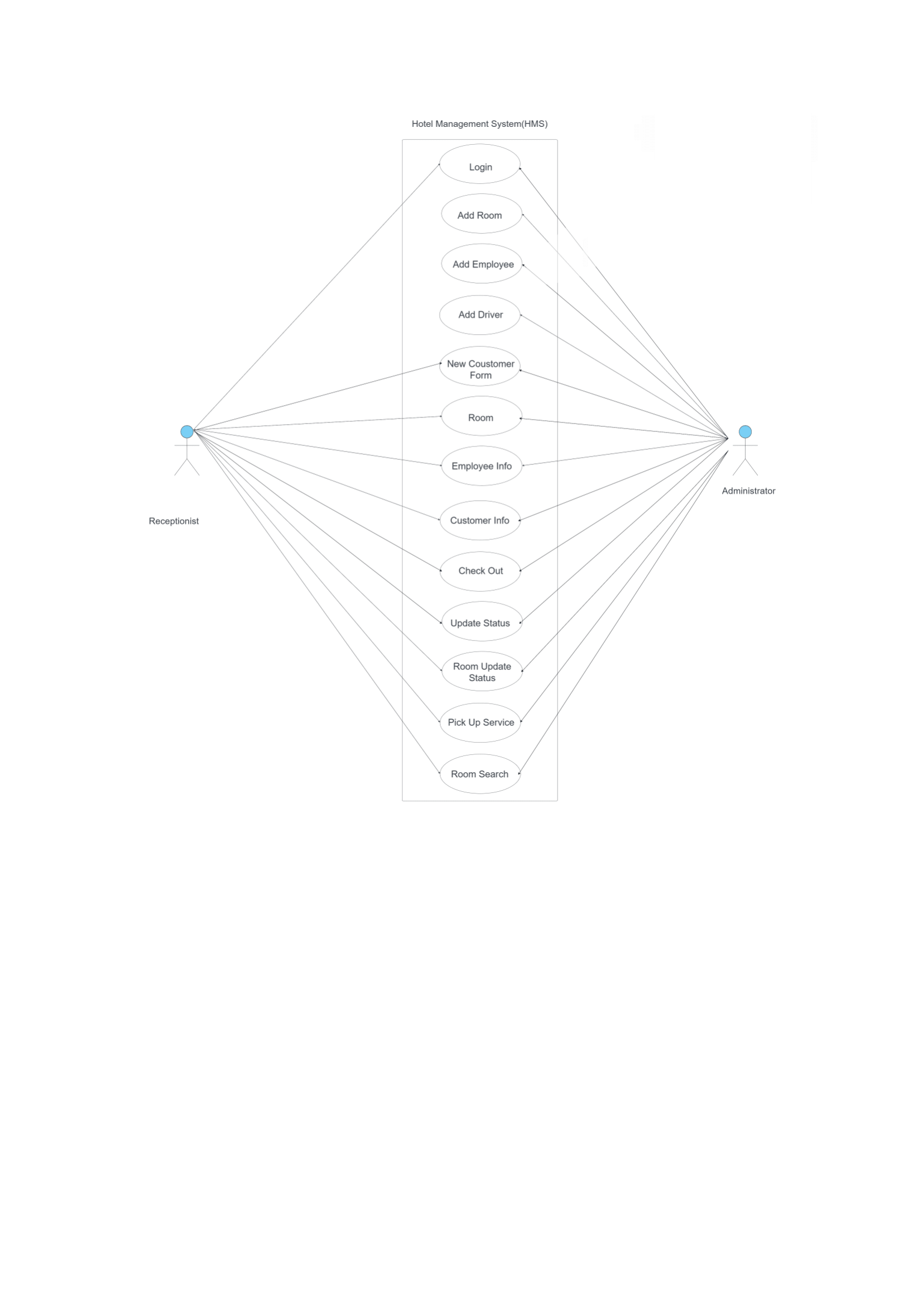

**Activity Modelling of Admin**

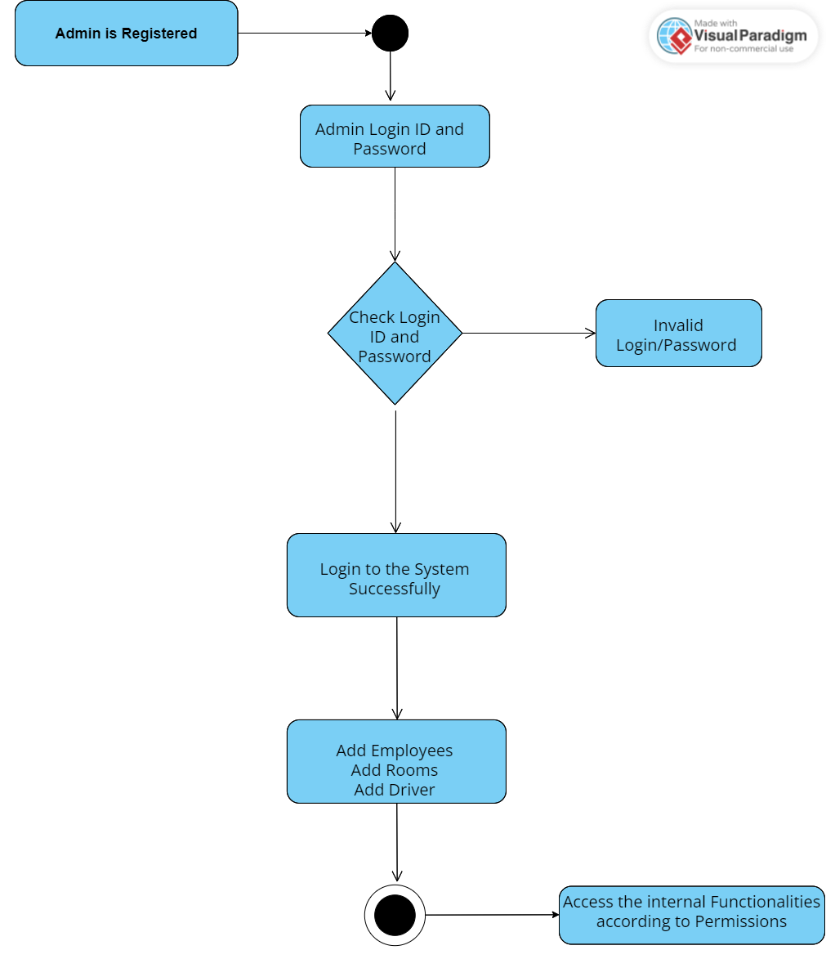

**Activity Modelling of Receptionist**

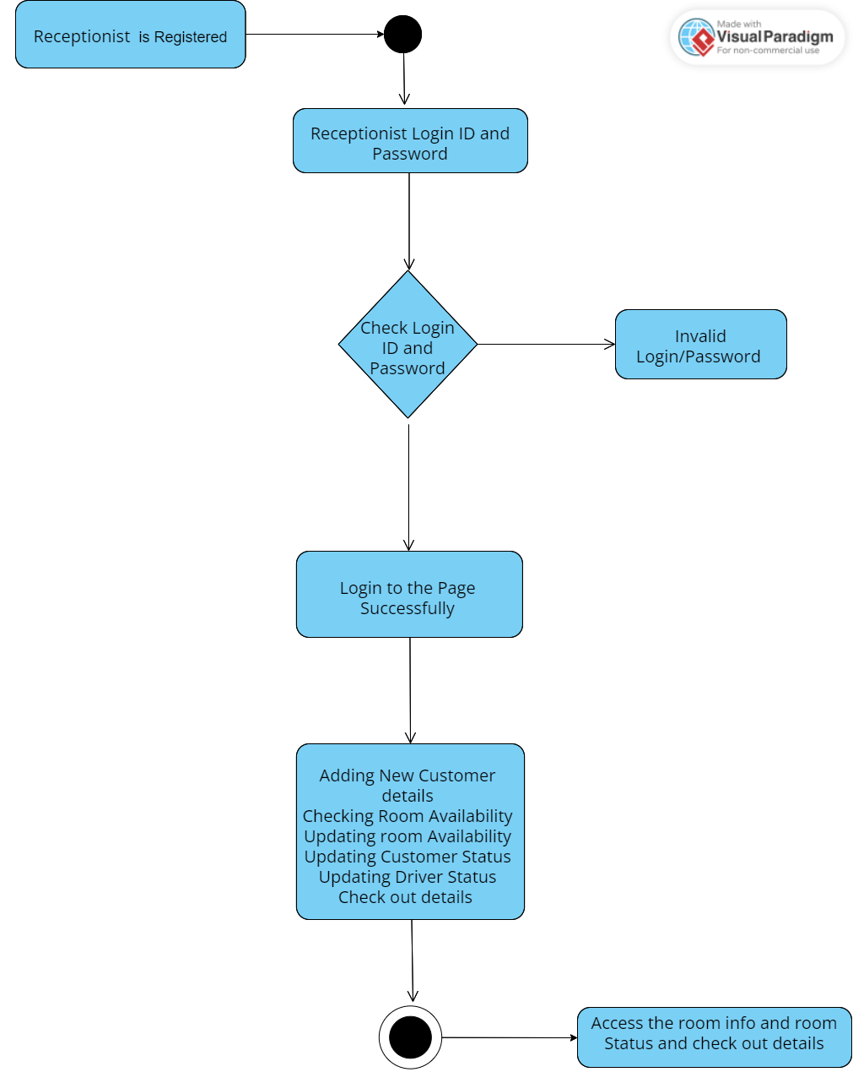

**Annexure (Sample Screens)**

**Login Page:**

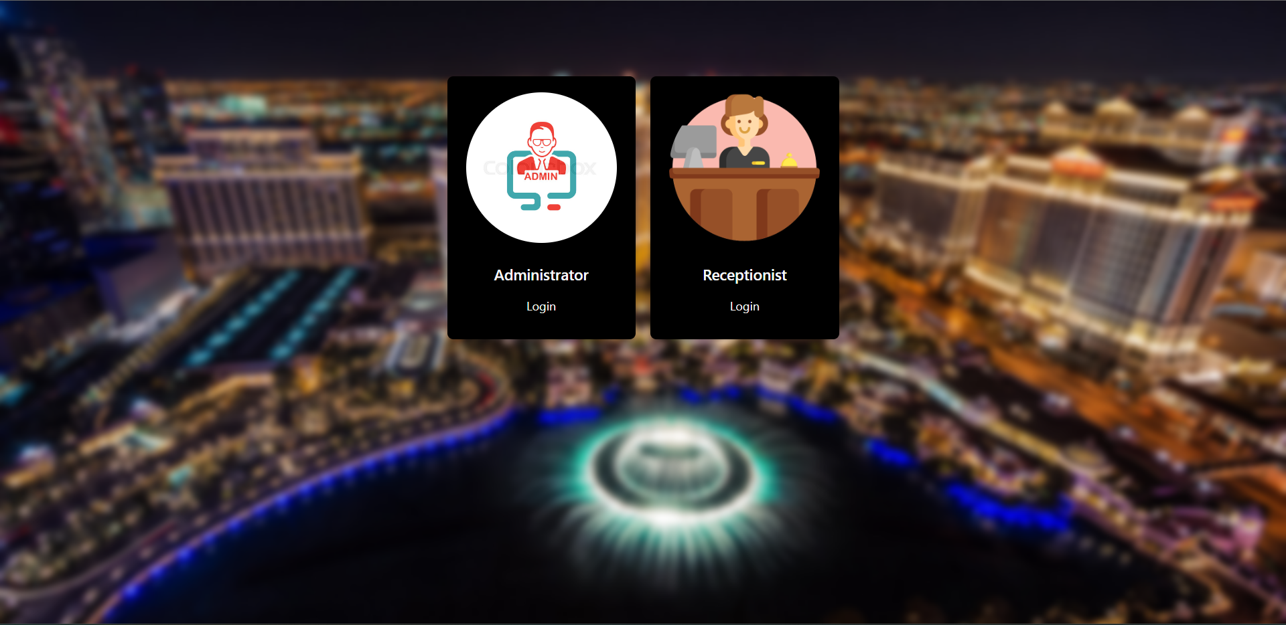

**Administrator Login Page**

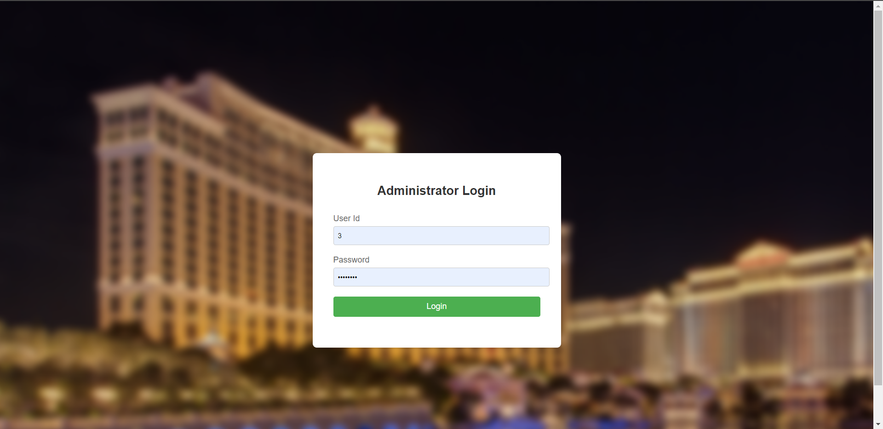

**Receptionist Login Page:**

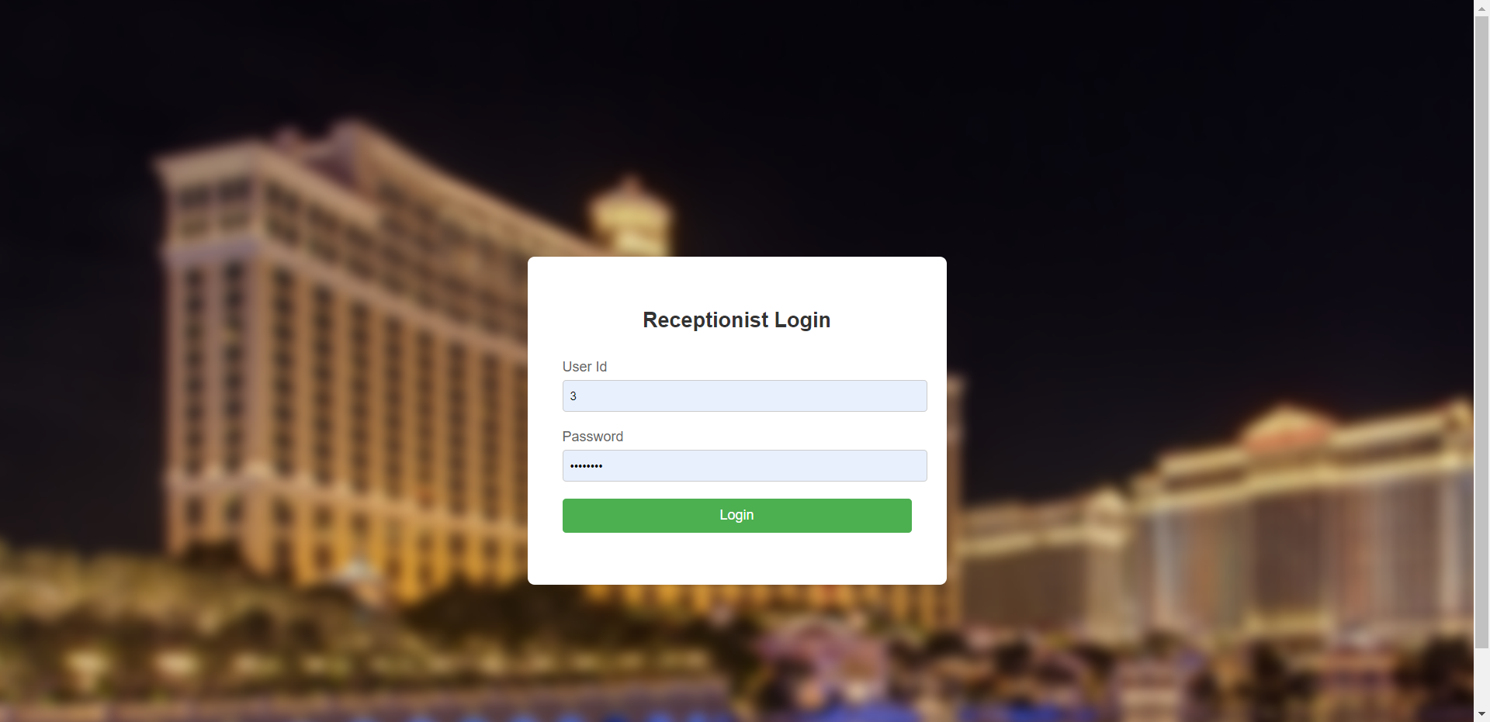

**Home Page:**

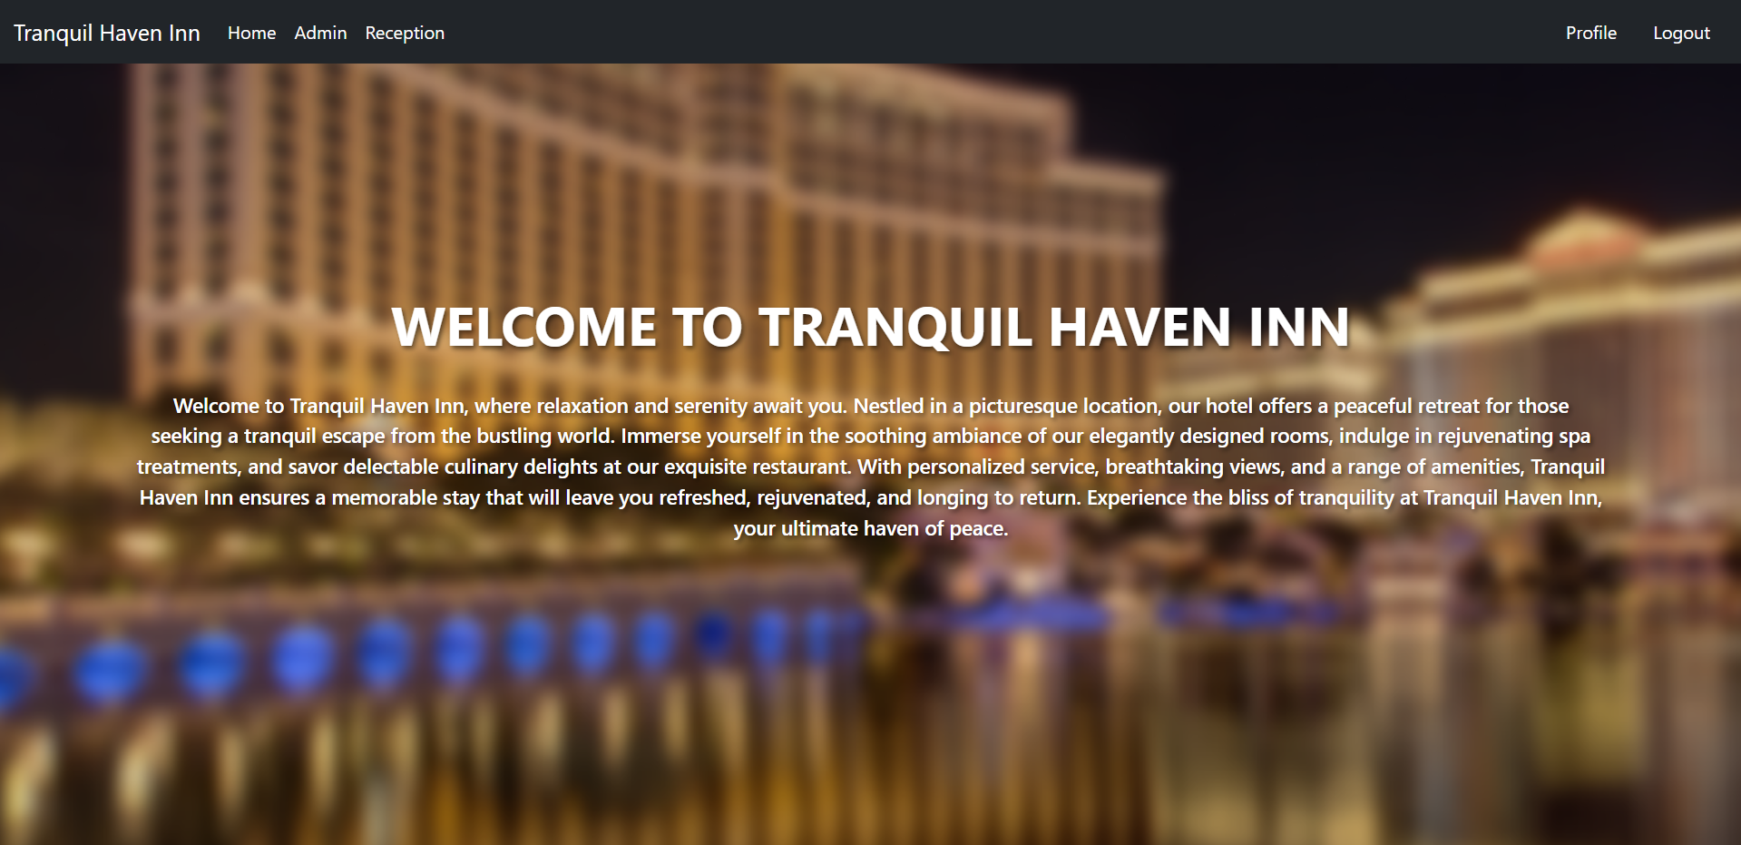

**Admin page:**

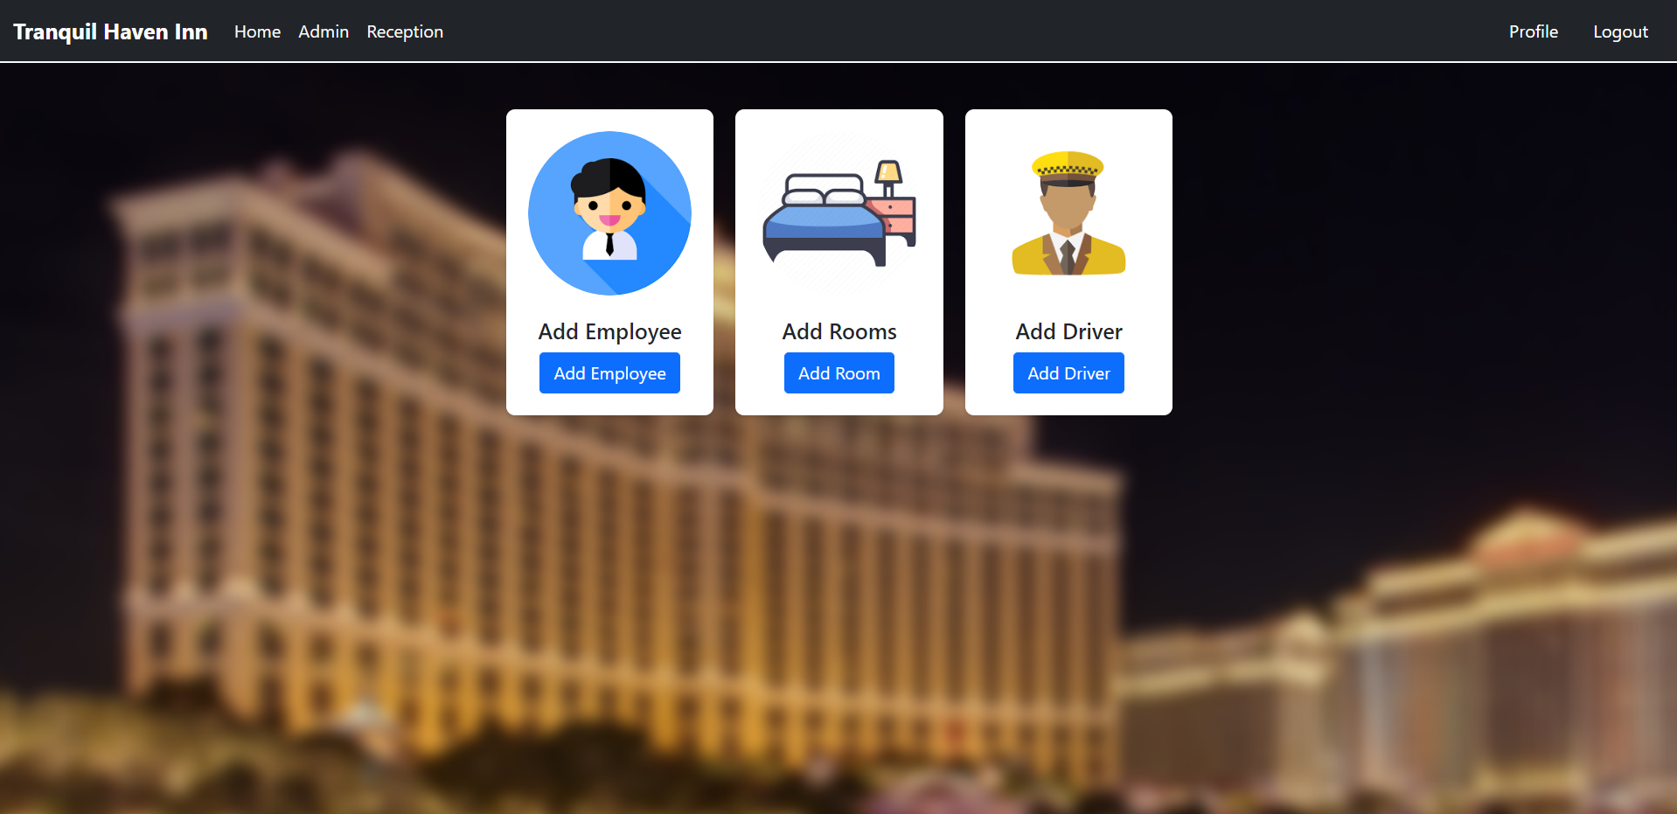

**Add Employee Page:**

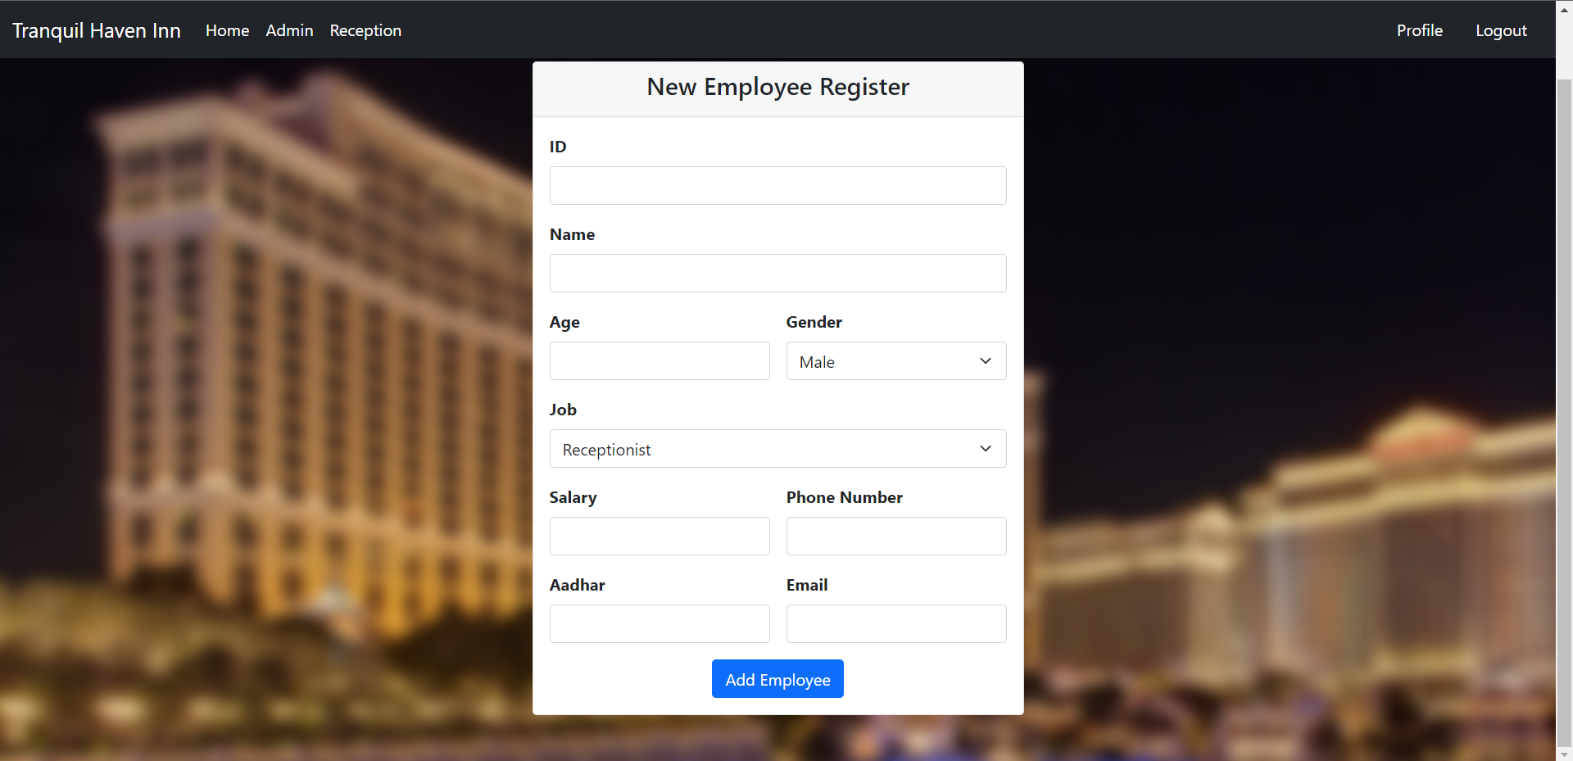

**Add Room Page:**

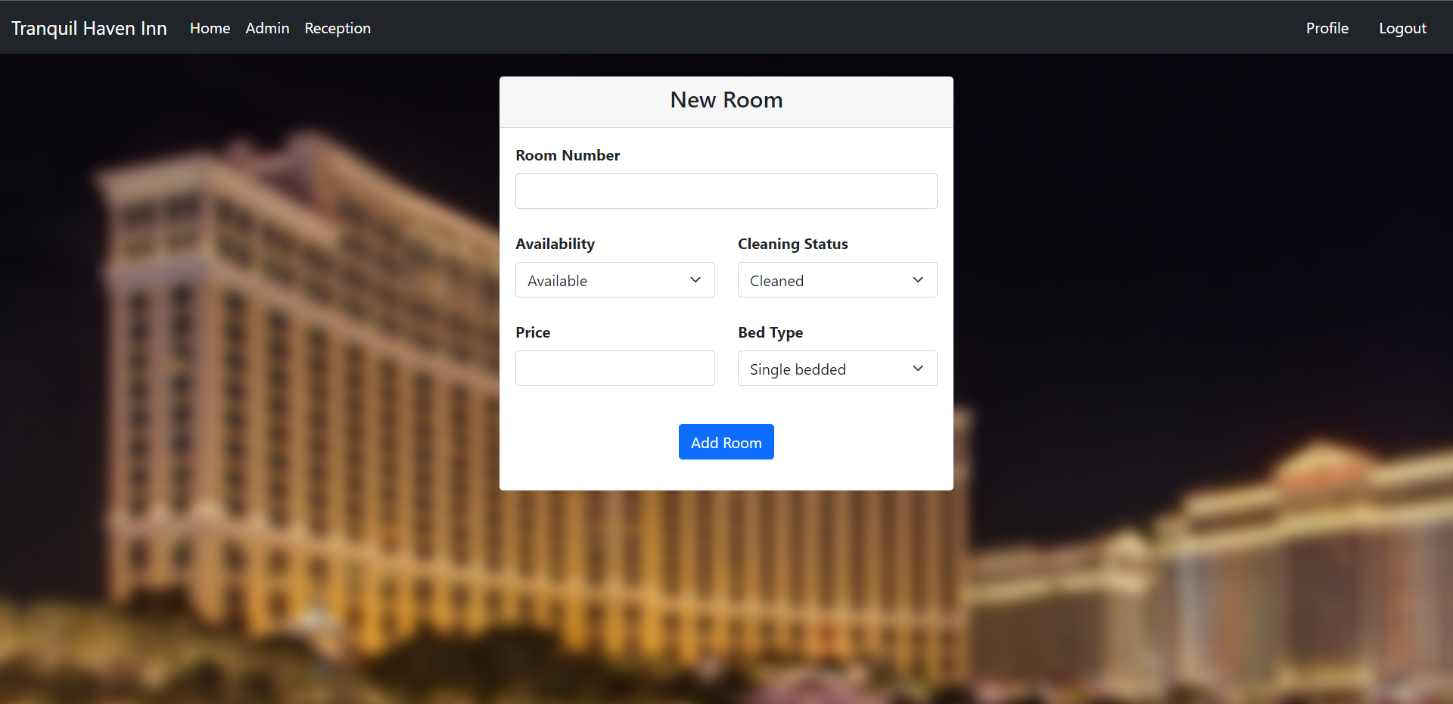

**Add Driver Page:**

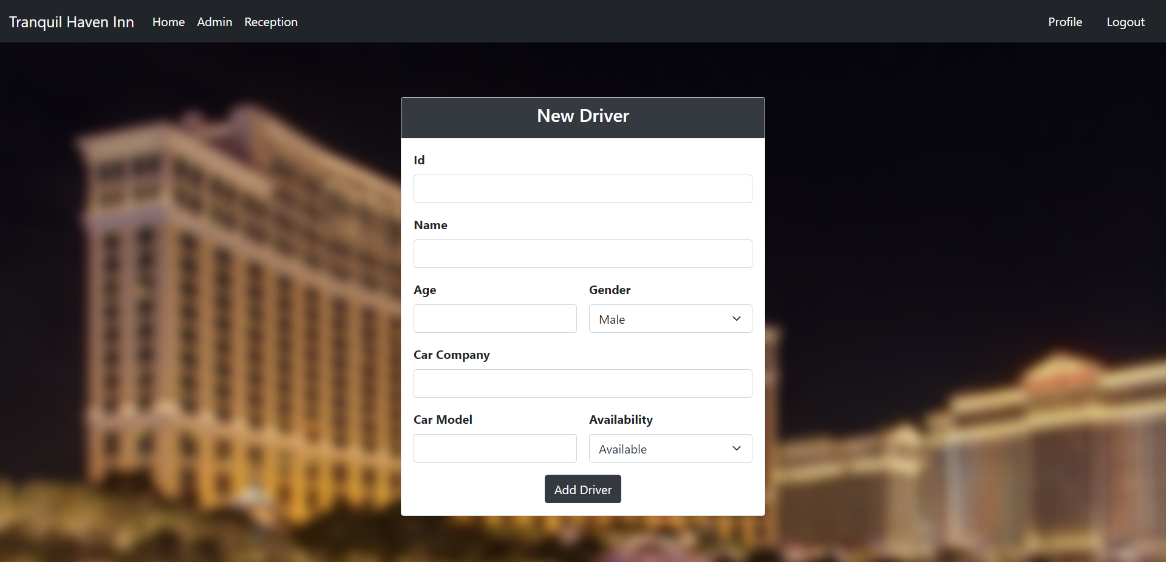

**Reception Page:**

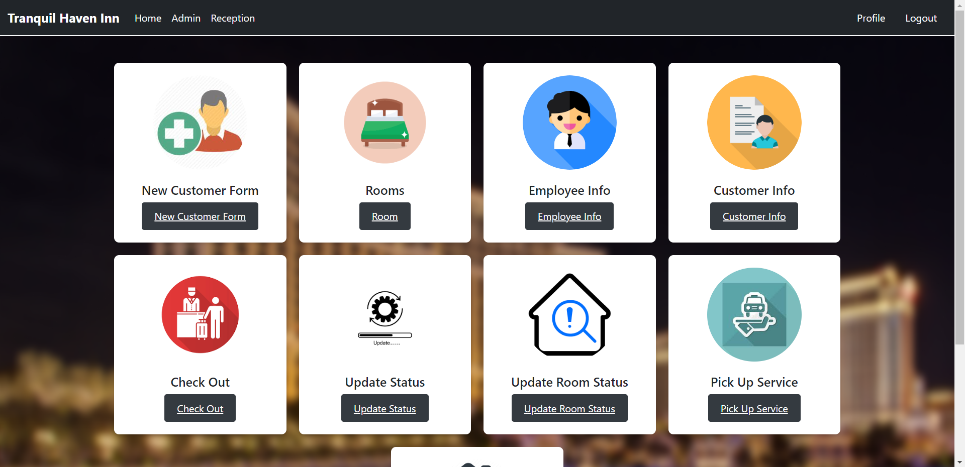

**New Customer Form Page:**

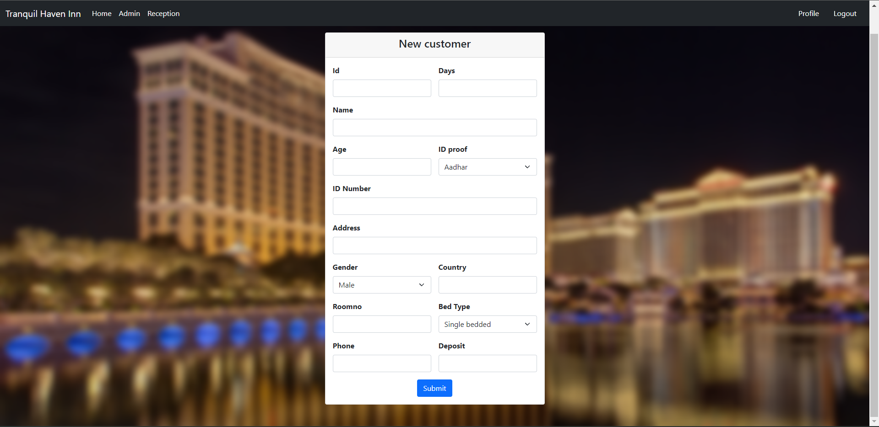

**Room Page:**

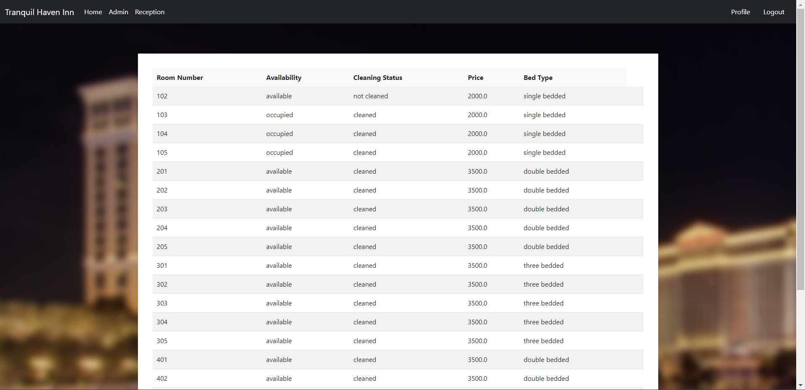

**Employee Info Page:**

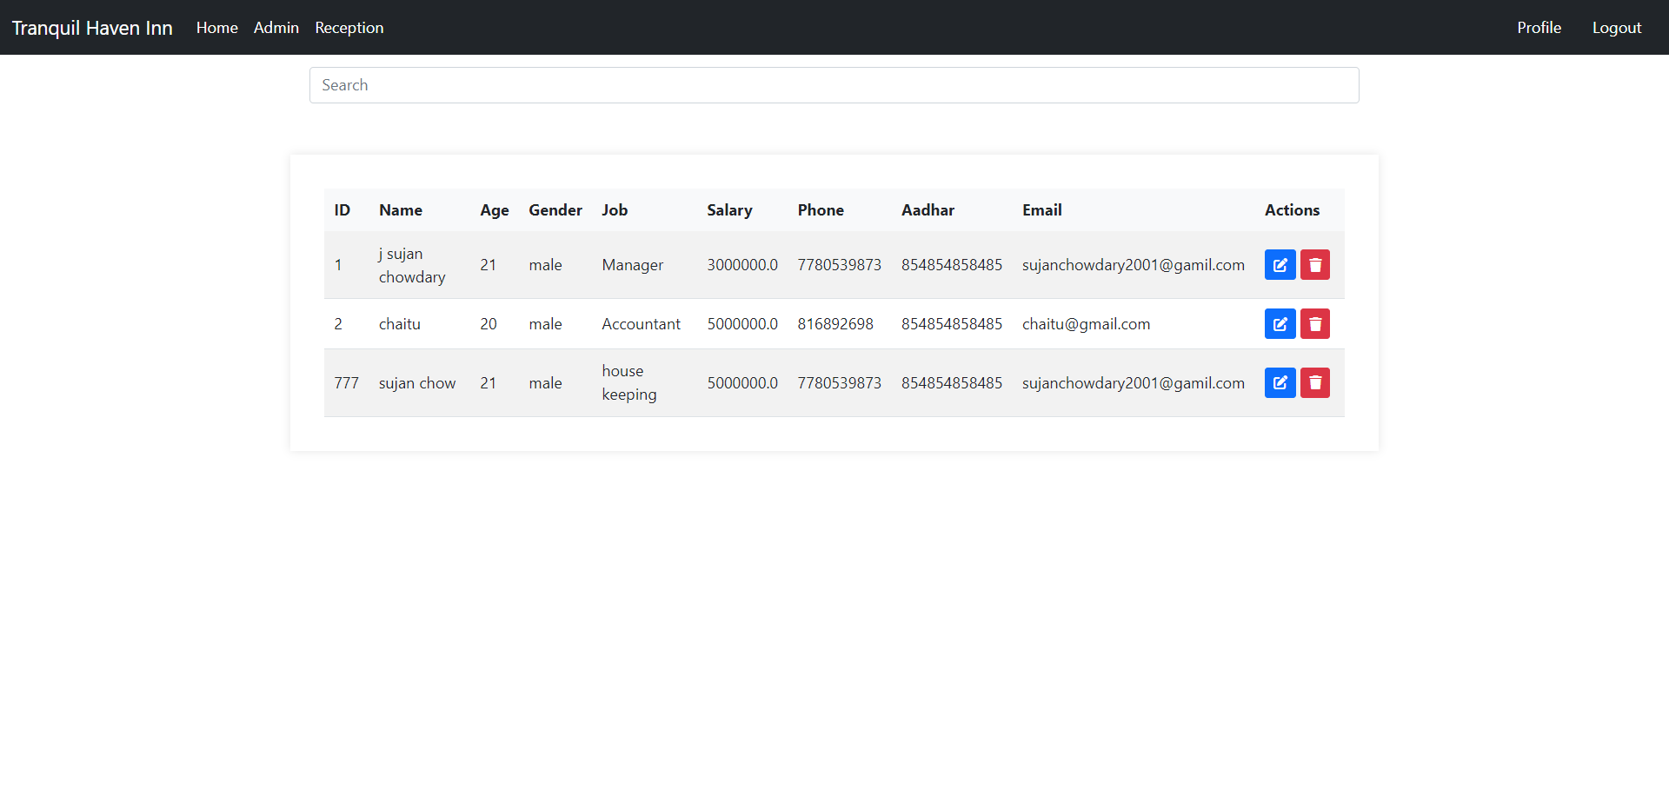

**Customer Info Page:**

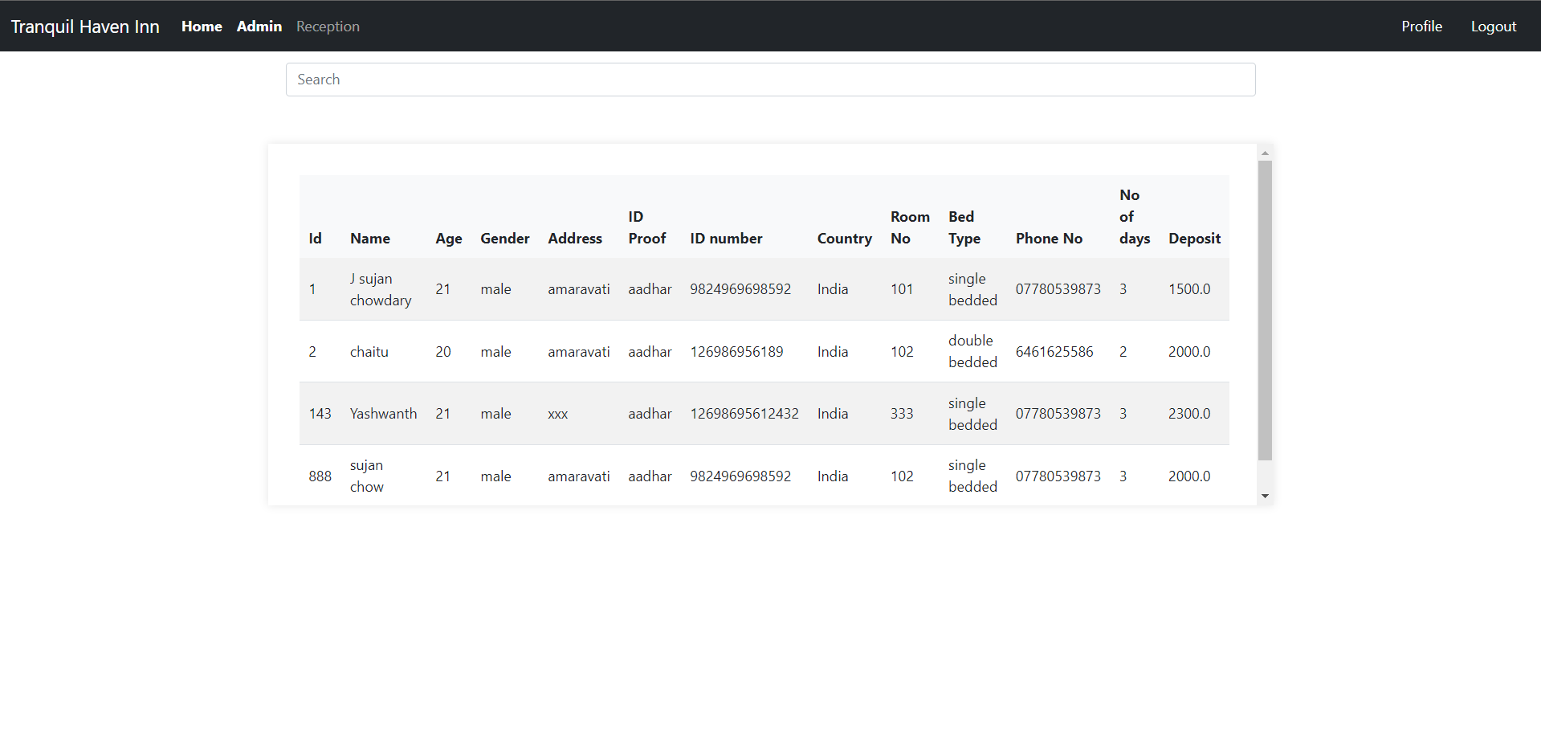

**Check Out Page:**

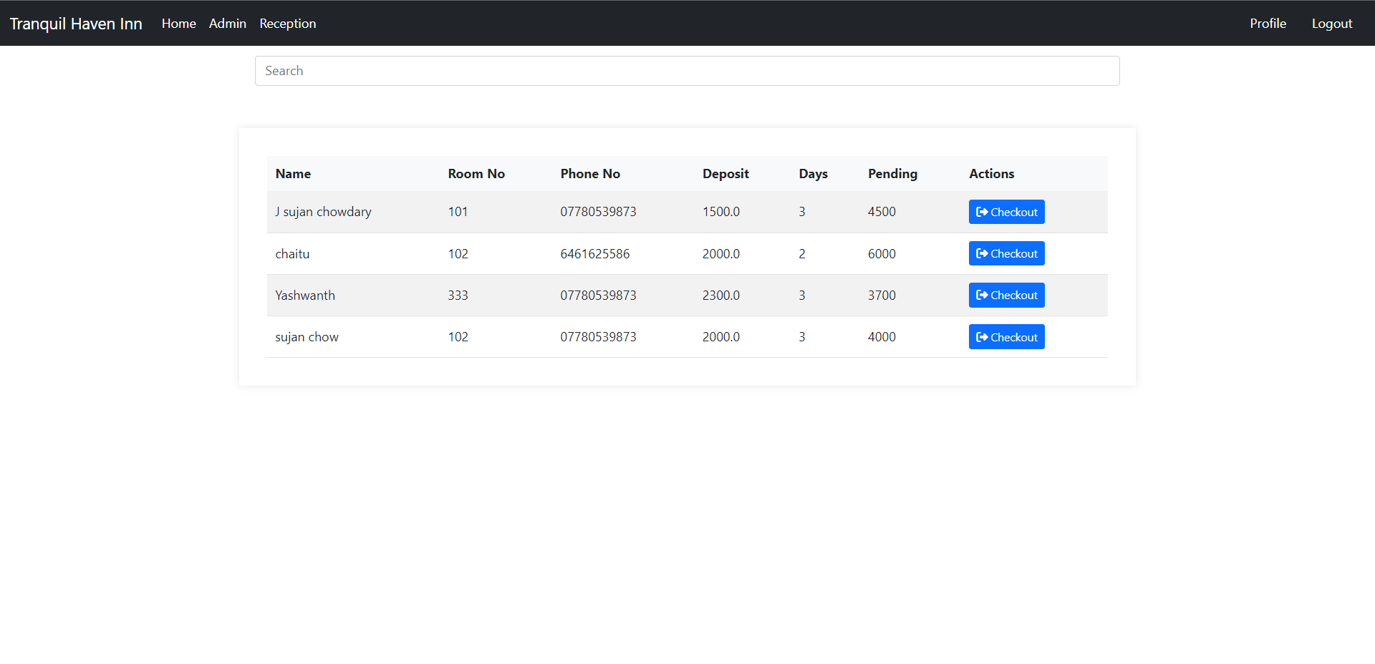

**Update Status Page:**

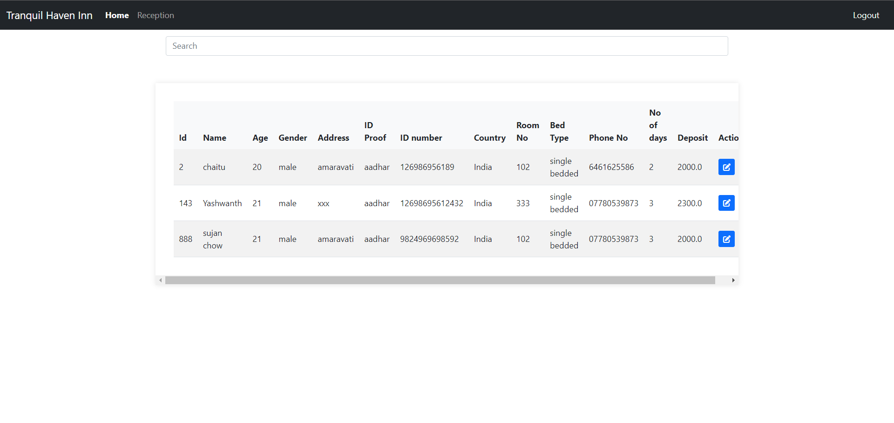

**Update Room Status Page:**

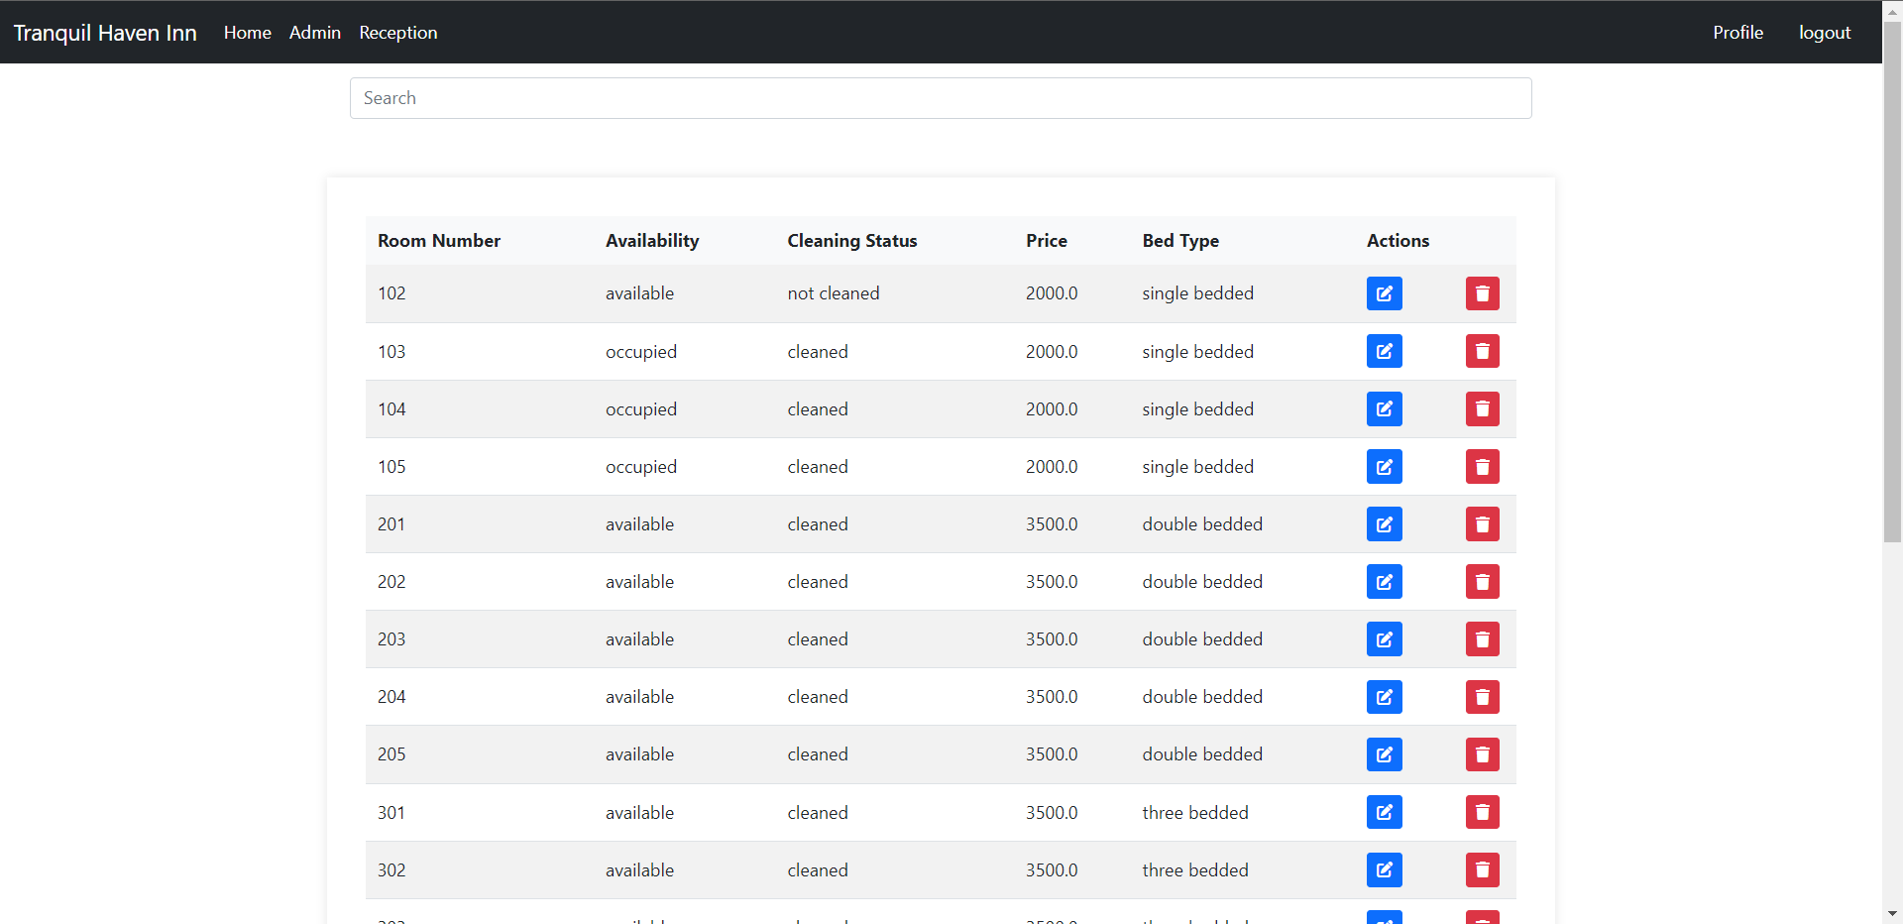

**Pick Up Service Page:**

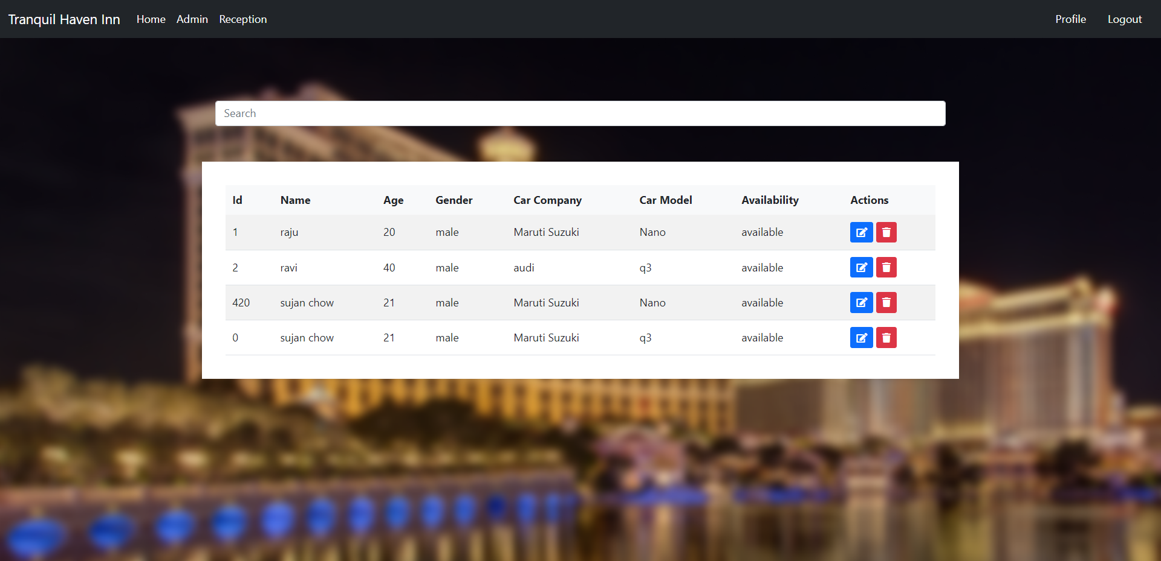

**Room Search Page:**

